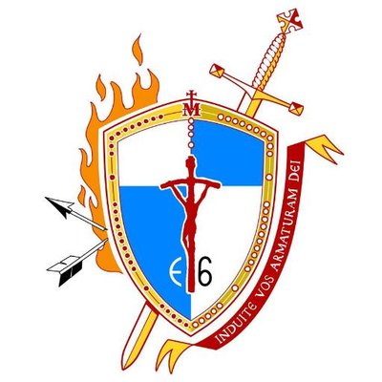
FOR IMMEDIATE RELEASE
Contact: Andrew Middendorf – 859.394.5855
Joe Yunger – 859.486.3289
contact@e6catholicmensconference.com

2023 E6 CATHOLIC MEN’S CONFERENCE
Armor Up!

St. Leon, IN (December 1, 2022) – The 8th annual E6 Catholic Men’s Conference will be on February 18th, 2023, at the East Central H.S. Performing Arts Center in St. Leon, Indiana, 35 minutes northwest of Cincinnati. The conference will be held from 8:00am to 3:30pm. Our speaker lineup this year includes the following:

Matt Birk (born July 23, 1976) is a former American football center. He was drafted by the Minnesota Vikings in the sixth round of the 1998 NFL Draft, and later played for the Baltimore Ravens. He played college football at Harvard. Birk is a two-time All-Pro, six-time Pro Bowl selection, and one-time Super Bowl champion.
Birk established the HIKE Foundation in 2002, which seeks to "impact the lives of at-risk children by providing interactive programs and resources needed to guide a child through the key educational transitions between elementary, middle, high school and college." The foundation launched "Ready, Set, Read!" in select Baltimore area public schools in the fall of 2010. The program works with about 100,000 Baltimore students on improving their reading skills through an incentive-based system. Birk received the Walter Payton Man of the Year Award in 2011 for his commitment to improving literacy among at-risk youth. Birk is a pro-life father of six children. His wife volunteers at a crisis pregnancy center and he participated in the Maryland March for Life in 2011.
Bear Woznick is the host of Motorcycle Based Reality TV show “Long Ride Home with Bear Woznick”. Distributed worldwide on EWTN and Armed Forces Network to more than two hundred million homes and Amazon Prime Video. He is the host of EWTN’s “The Bear Woznick Adventure” Radio Show heard by millions each week on over 500 radio stations in nearly all 50 states as well as Sirius FM and global shortwave and internet radio and YouTube. Bear is also the host of the daily “Catechism in a Year” seen daily on Facebook live and YouTube. He is the author of the Sophia Institute’s books “Deep in the Wave – A Surfing Guide to the Soul” (an Amazon best seller), “Deep Adventure – The Way of Heroic Virtue” and his Fall 2022 book “12 Rules for Manliness - Where Have all the Cowboys Gone?” H﻿e is a world champion surfer involved with coaching a dozen teams and co-founding the Professional International Tandem Surfing Association world tour. Bear is married with four adult children. Now lives in Hawaii with his wife Cindy.
Fr. Jonathan Meyer was ordained a priest in 2003 for the Archdiocese of Indianapolis. After his ordination he served as the Director of Youth and Young Adult Ministry for the Archdiocese. He has also served at several parishes, prior to being named as the pastor of four parishes in Dearborn County, IN.
He maintains a presence on the internet with weekly homilies and other teachings. He has written and published two children’s plays and recently wrote a chapter for Dynamic Catholic’s book, Beautiful Hope. In 2022 he began minister as a National Preacher for the Eucharistic Revival.
In his spare time, he coaches Track and Cross Country; coaching at public schools for the past 12 years.

The E6 Catholic Men’s Conference is designed to bring men into a deeper relationship with Christ and His Catholic Church through: a worthy celebration of the sacraments, engaging talks to strengthen their faith, opportunities for true fraternity and exposure to good resources to aid them in living their faith as Disciples of Christ. In a world that is losing a truly biblical understanding of masculinity, fatherhood and brotherhood, this conference aims at equipping men to put on the Armor of God (Ephesians 6:10-18) and stand as men of Christ. The E6 Catholic Men’s Conference over the past few year has been overwhelming success, and 2022 looks to be bigger and better.

Admission is $40 for registration until 2.17.2023. Lunch included. Sponsorship and limited vendor opportunities are available, please visit www.e6cmc.com for more information.

www.e6cmc.com
www.facebook.com/E6Mensconference
https://twitter.com/E6Conference
#e6conference

